EX-2:STAR TOPOLOGY
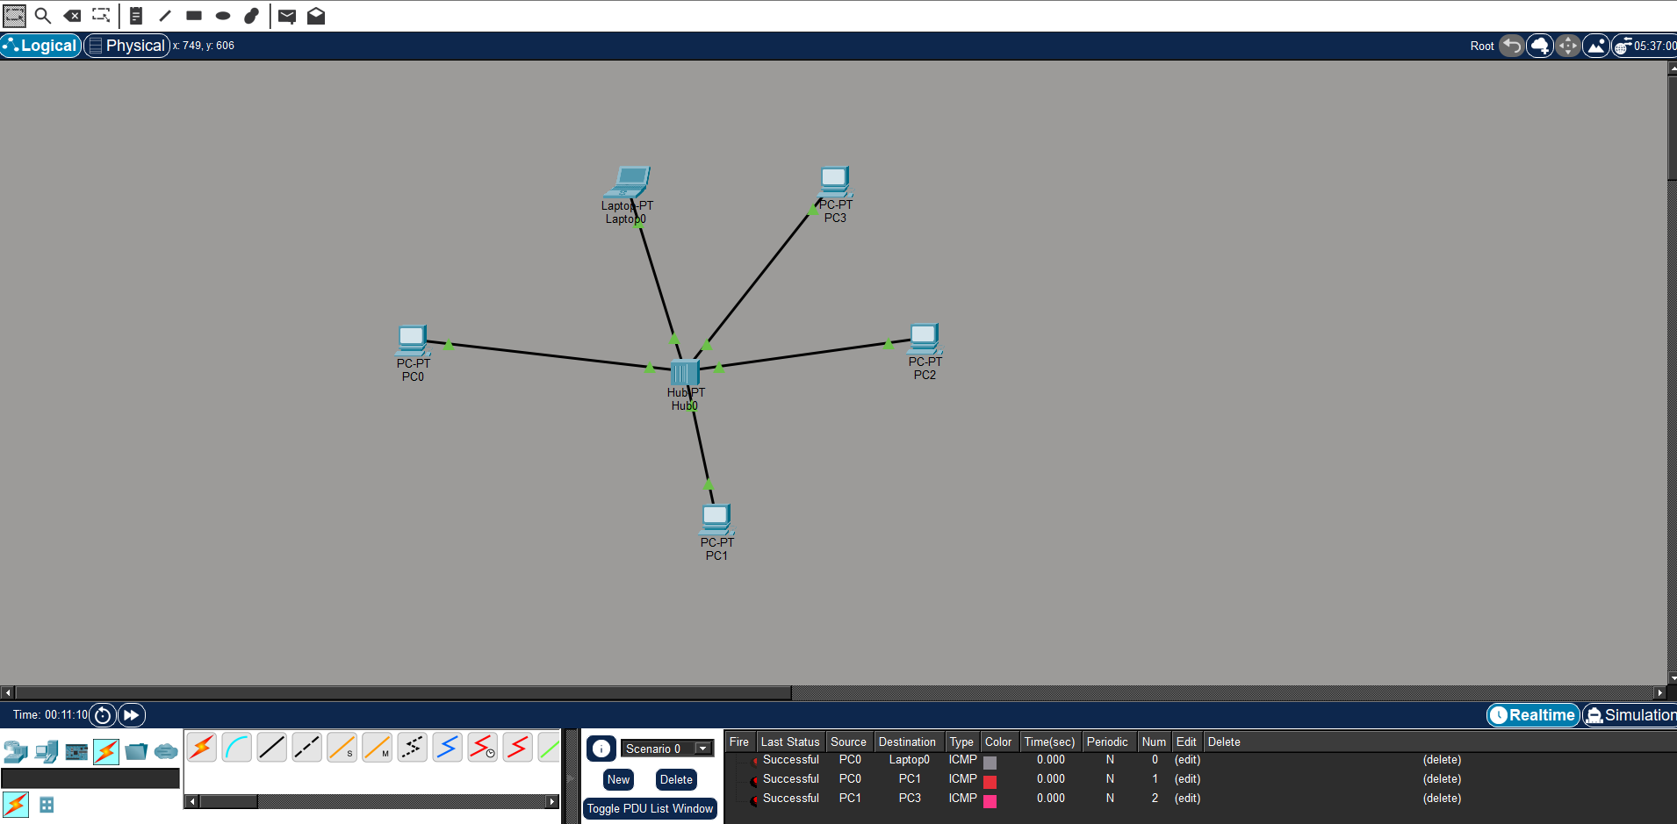

EX-3:BUS TOPOLOGY
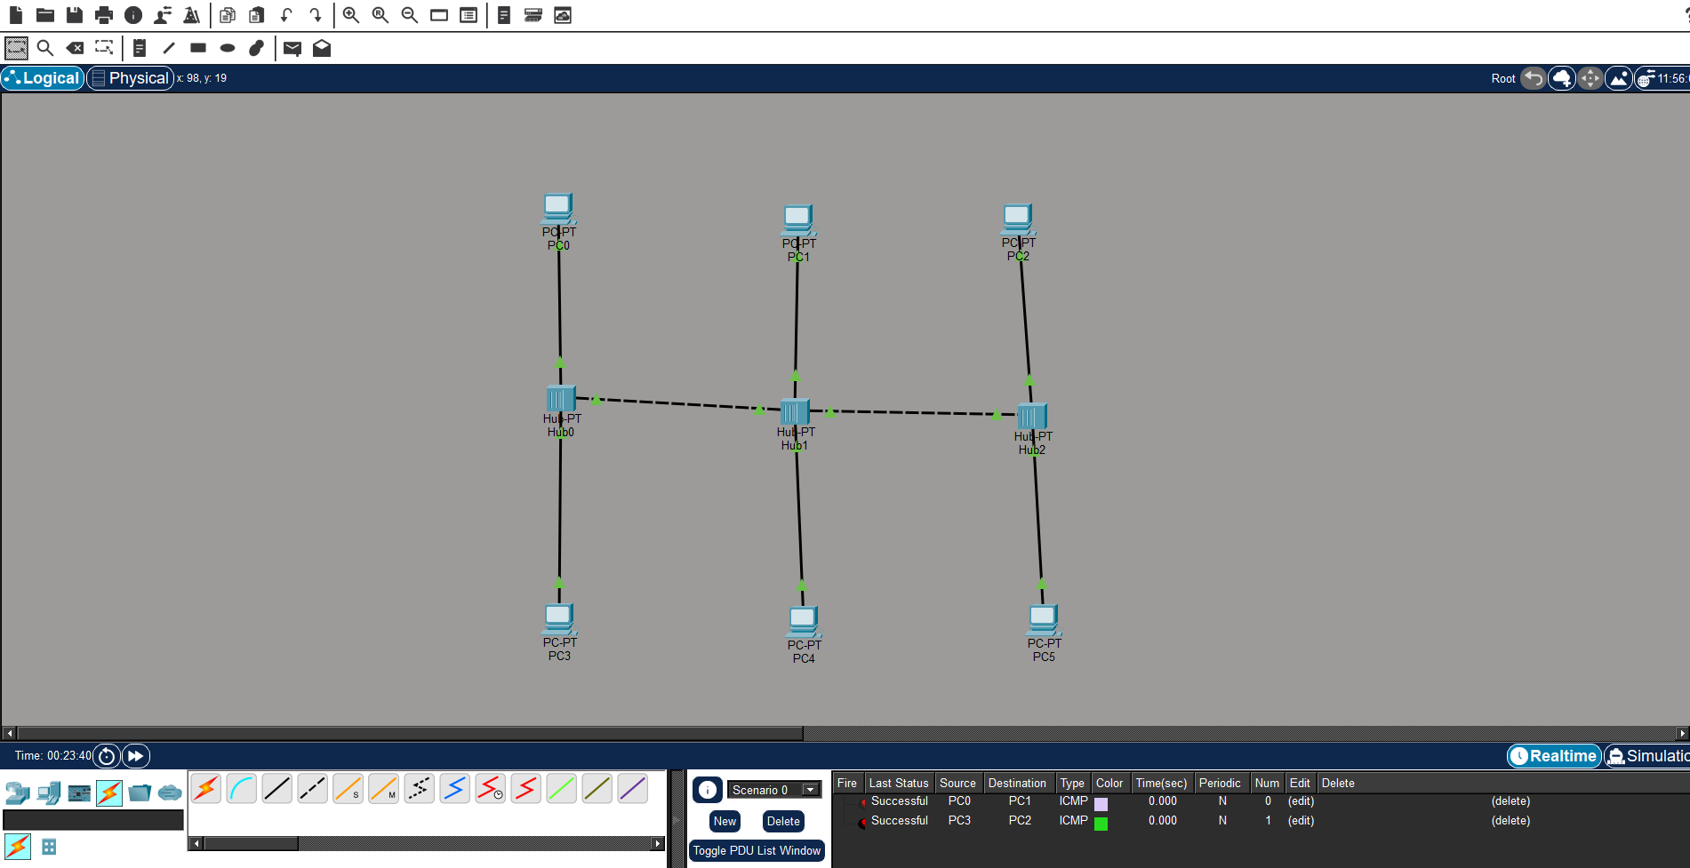

EX-4:RING TOPOLOGY
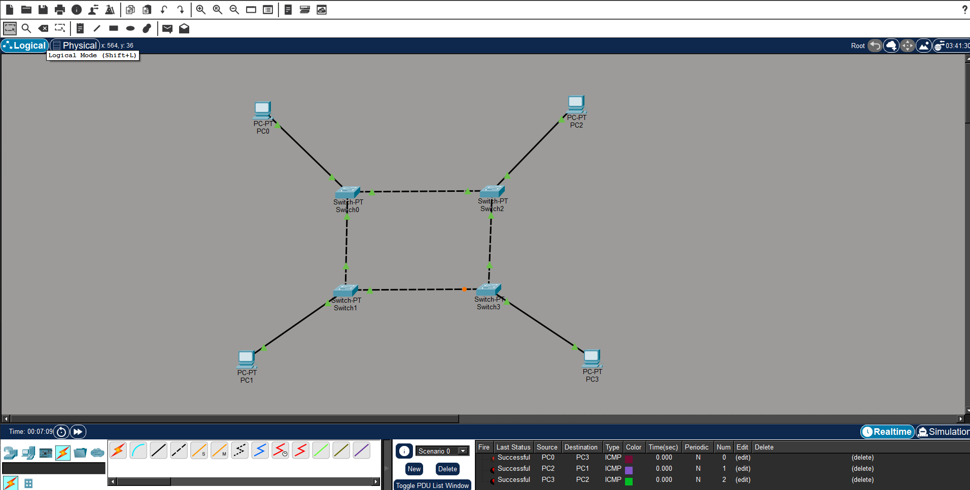

EX-5:MESH TOPOLOGY

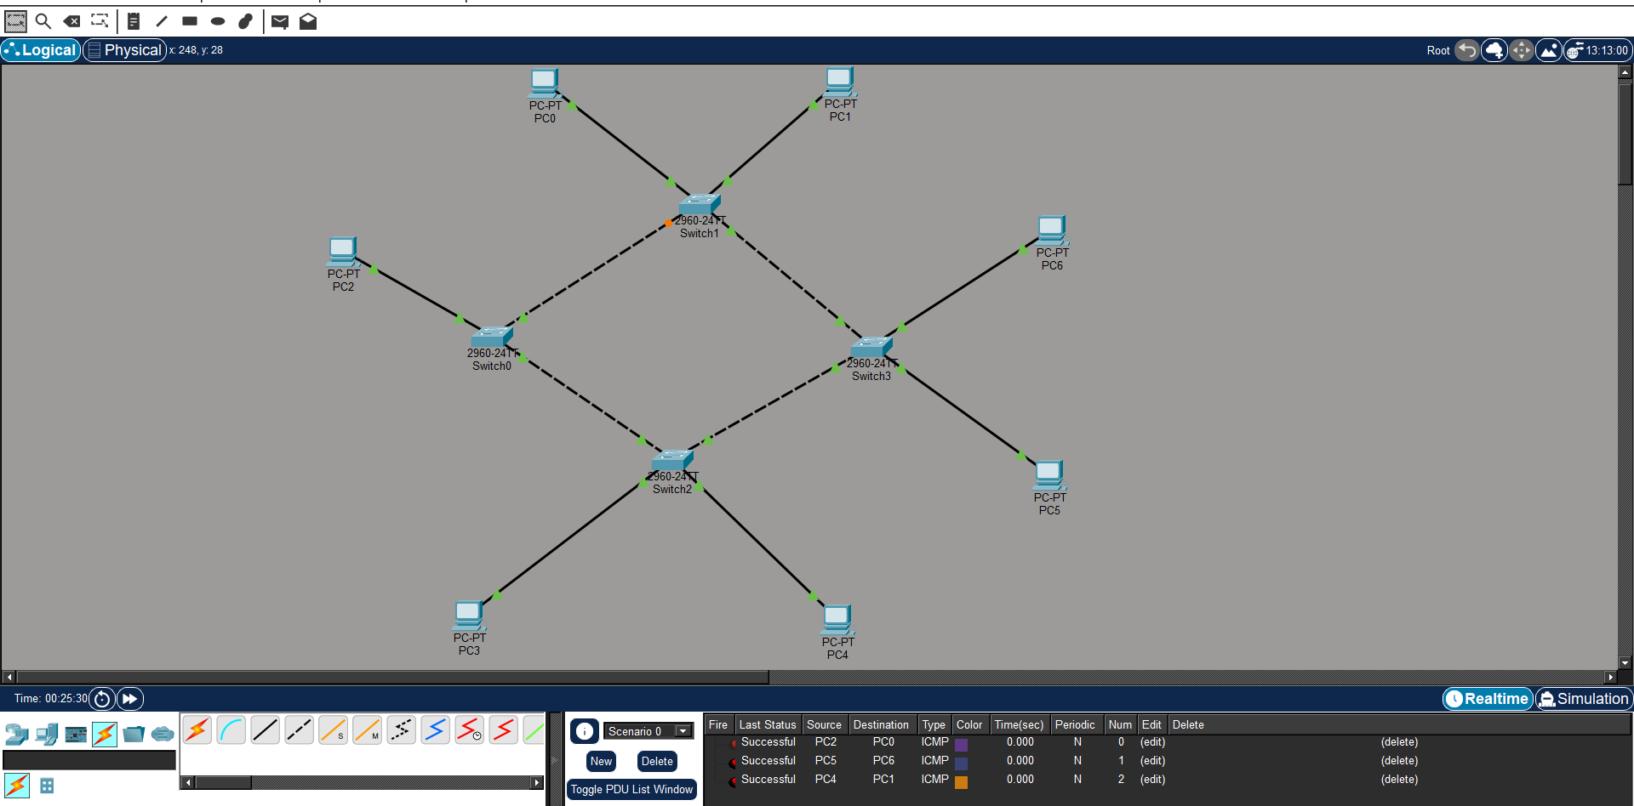

EX-6:TREE TOPOLOGY
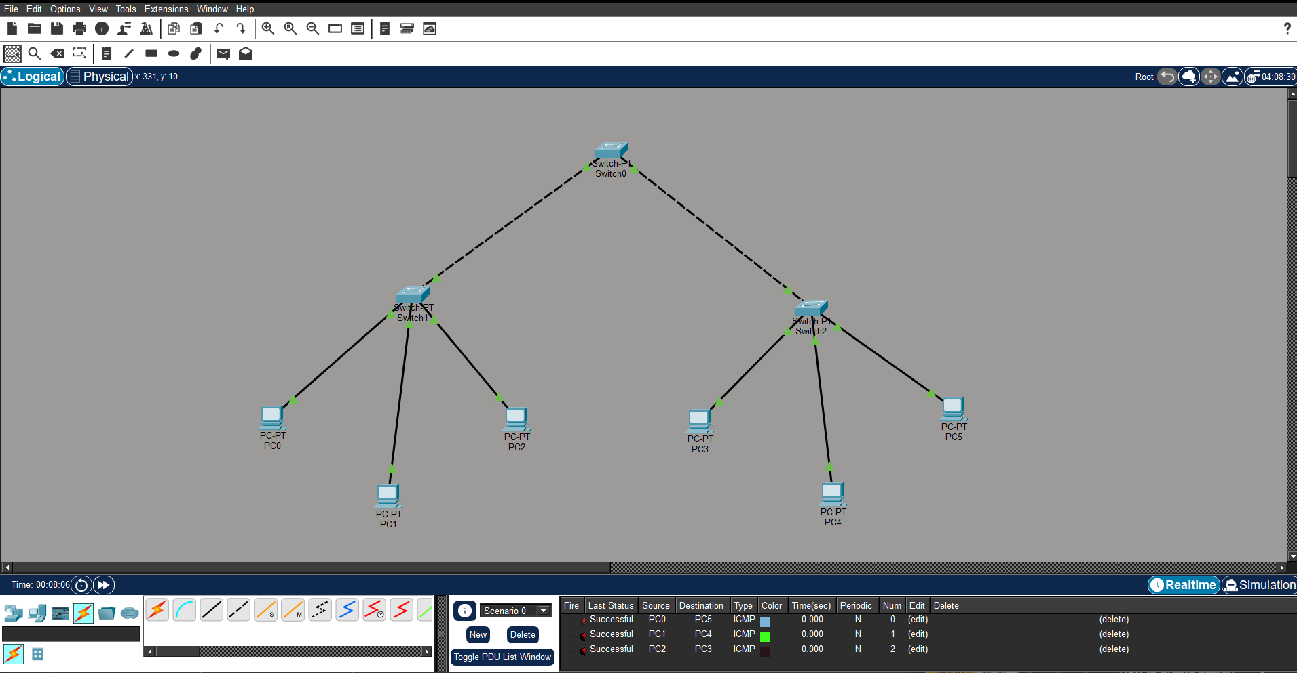

EX-7: HYBRID TOPOLOGY
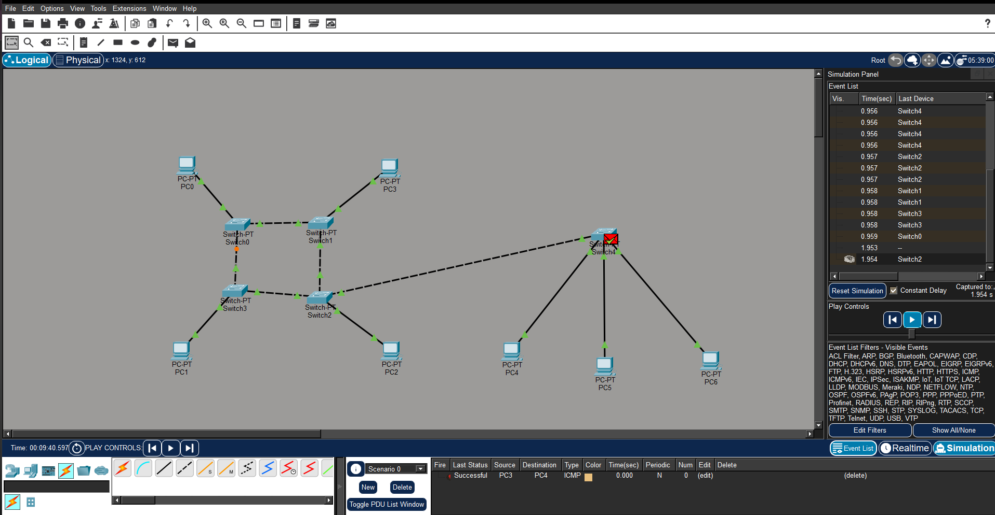

Ex-8:
